# Fooride paigutus

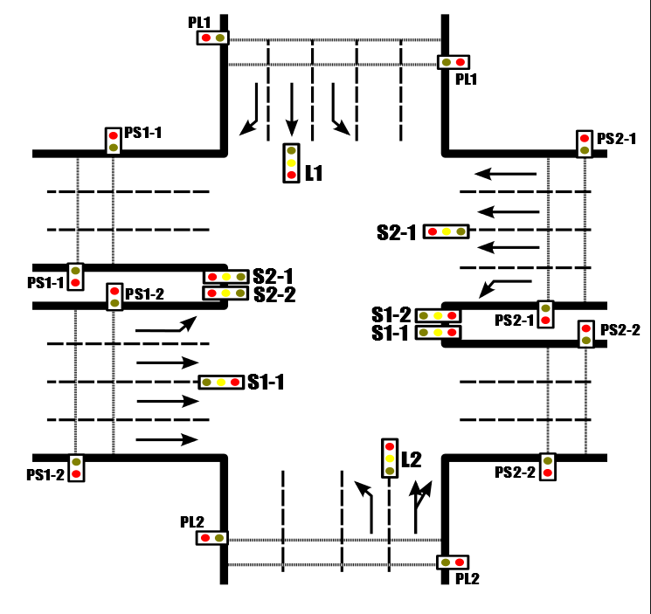

## Sõpruse pst. suunaga Kristiine poolt ( S1 )

**S1-1** Otsesuund

**S1-2** Vasakpöörde suund

**PS1-1** Jalakäijate foor #1

**PS1-2** Jalakäijate foor #2

## Sõpruse pst. suunaga Mustamäe poolt ( S2 )

**S2-1** Otsesuund

**S2-2** Vasakpöörde suund

**PS2-1** Jalakäijate foor #1

**PS2-2** Jalakäijate foor #1

## Linnu tee suunaga Tondi poolt (L1)

**L1** Kõik suunad

**PL1** Jalakäijate foor

## Linnu tee suunaga Haabersti poolt ( L2 )

**L2** Kõik suunad

**PL2** Jalakäijate foor

# Fooride tsükkel

|  |  |  |  |  |  |  |  |  |  |  |  |  |
| --- | --- | --- | --- | --- | --- | --- | --- | --- | --- | --- | --- | --- |
|  | **Sõpruse pst 1** | | | | **Sõpruse pst 2** | | | | **Linnu tee 1** | | **Linnu tee 2** | |
| **Viivitus** | **S1-1** | **S1-2** | **PS1-1** | **PS1-2** | **S2-1** | **S2-2** | **PS2-1** | **PS2-2** | **L1** | **PL1** | **L2** | **PL2** |
| 1 | P | P | P | R | P | K | P | R | P | P | P | P |
| 1 | P | P | P | R | K | R | P | R | P | P | P | P |
| 2 | P | P | P | R | R | R | P | R | P | P | P | R |
| 4 | P | P | P | P | R | R | P | R | P | P | P | R |
| 3 | P | P | P | P | R | K | P | P | P | P | P | R |
| 3 | P | P | P | P | R | P | P | P | P | P | P | R |
| 1 | K | P | P | P | R | P | P | P | P | P | P | R |
| 16 | R | P | P | P | R | P | P | P | P | R | P | R |
| 3 | R | P | P | P | R | P | P | P | P | R | P | P |
| 2 | R | P | P | P | K | P | P | P | P | R | P | P |
| 1 | R | K | P | P | K | P | P | P | P | R | P | P |
| 3 | R | R | P | P | P | P | P | P | P | R | P | P |
| 3 | R | R | P | P | P | P | R | P | P | R | P | P |
| 6 | R | R | R | P | P | P | R | P | P | R | P | P |
| 3 | R | R | R | P | P | P | R | P | P | P | P | P |
| 3 | K | K | R | P | P | P | R | P | P | P | P | P |
| 1 | P | P | R | P | P | P | R | P | P | P | P | P |
| 1 | P | P | R | P | P | P | R | P | K | P | K | P |
| 1 | P | P | R | R | P | P | R | P | R | P | R | P |
| 24 | P | P | R | R | P | P | R | R | R | P | R | P |
| 2 | P | P | P | R | P | P | R | R | R | P | R | P |
| 2 | P | P | P | R | P | P | P | R | R | P | R | P |
| 3 | P | P | P | R | P | P | P | R | K | P | K | P |
| 1 | P | P | P | R | P | P | P | R | P | P | P | P |